MODULE1:

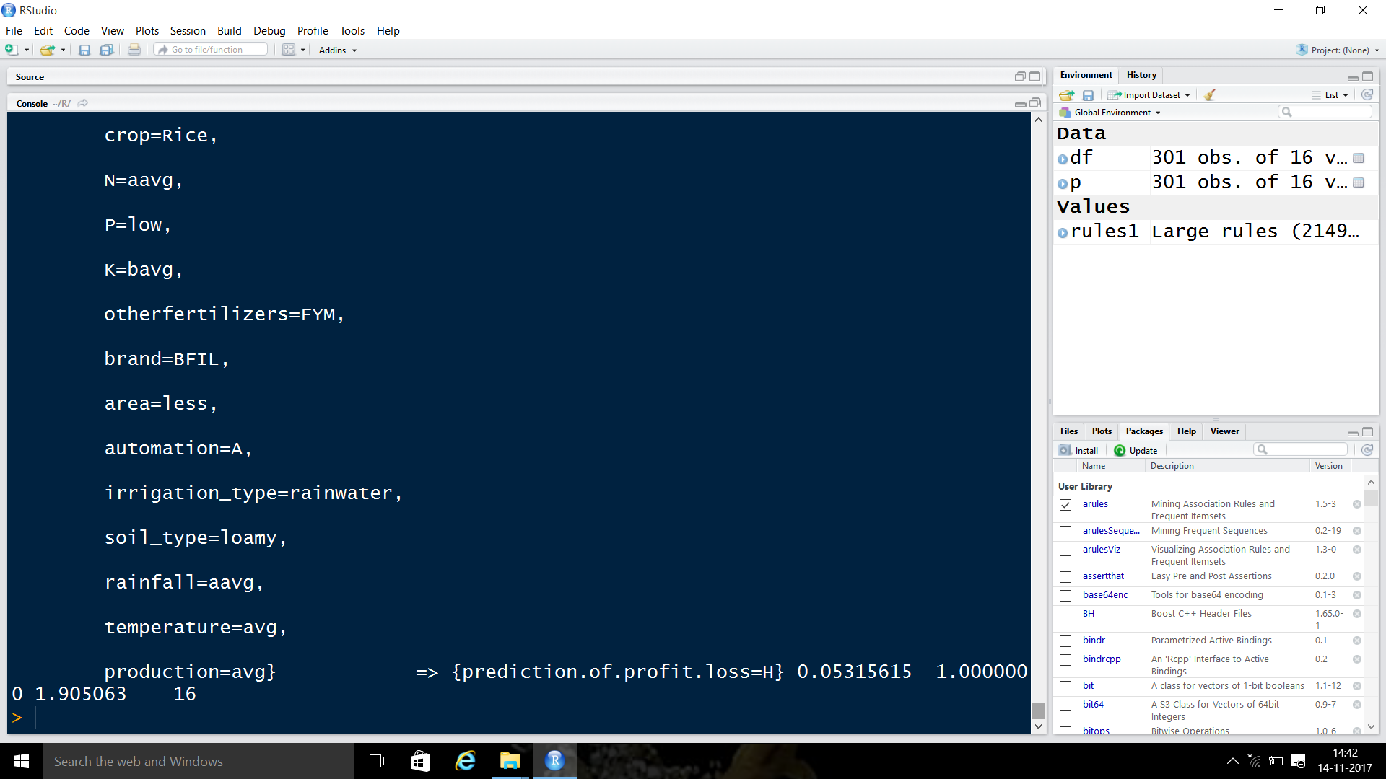

GENERATED ASSOCIATION RULES

MODULE2:

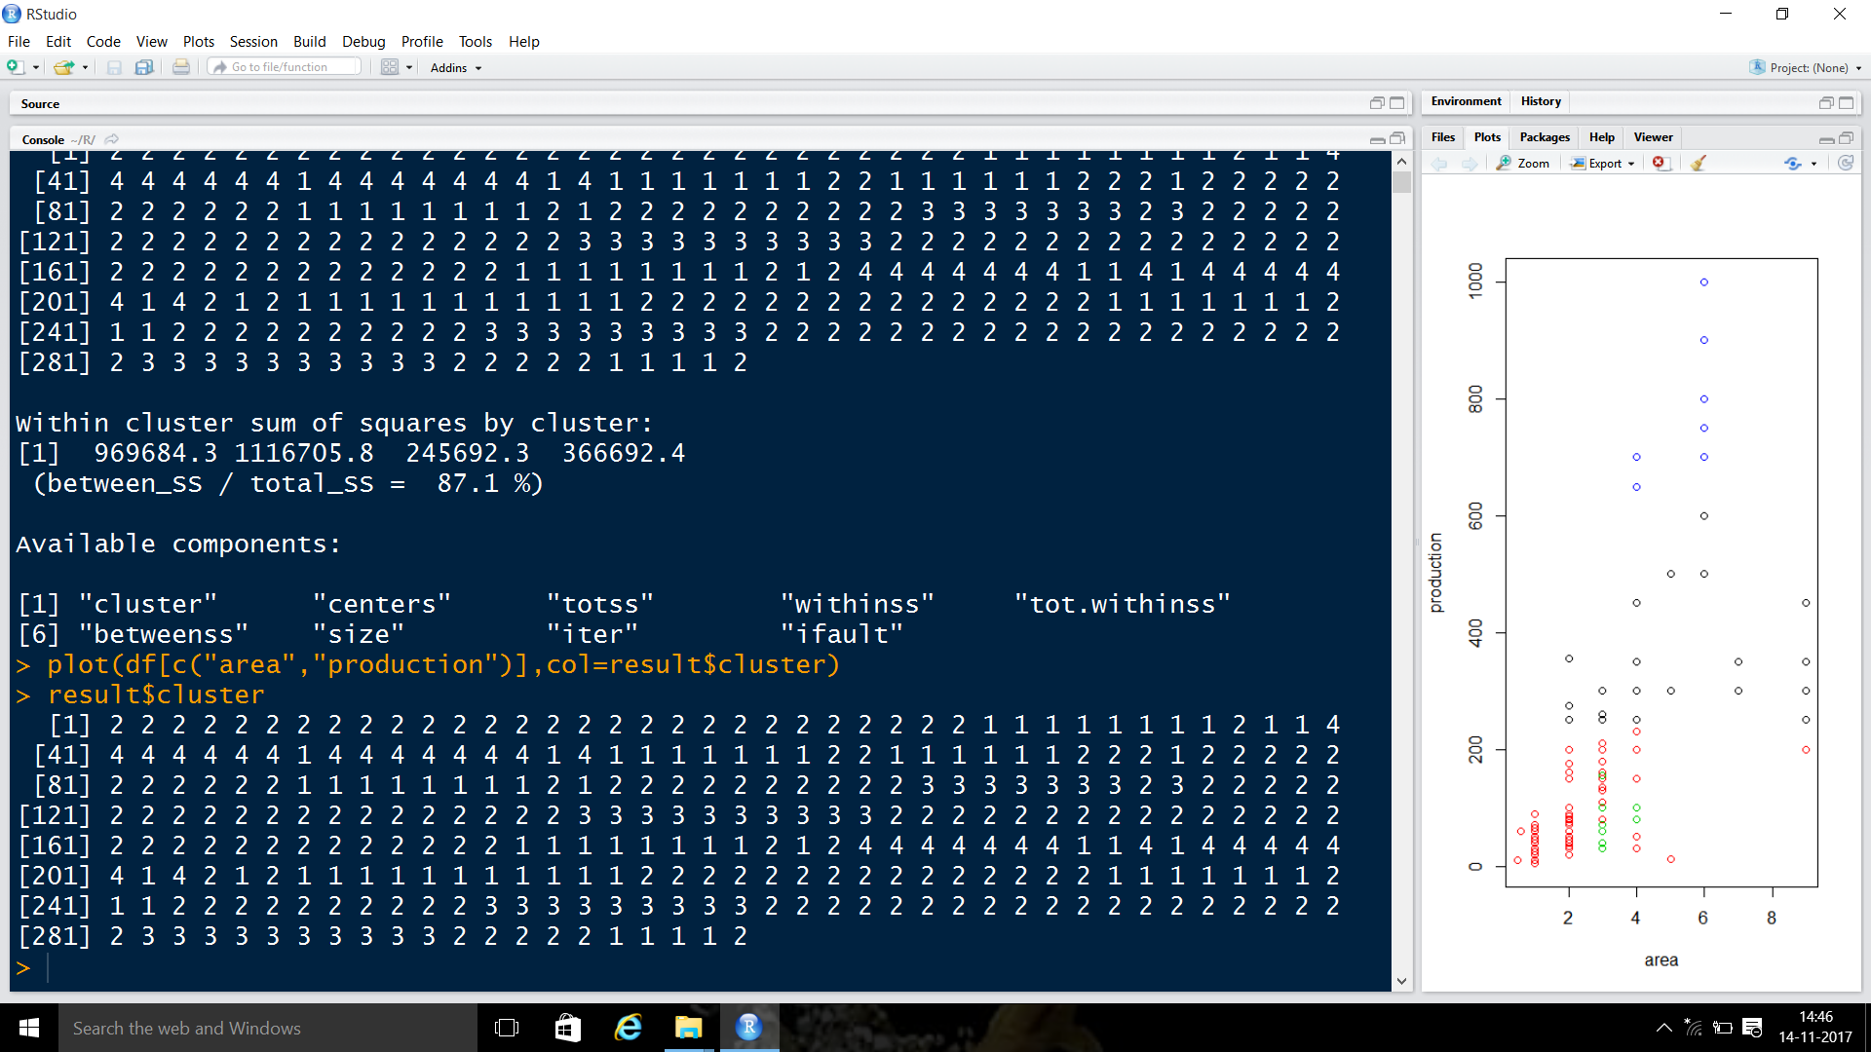

2D CLUSTERS FORMED WITH THE EXISTING DATASET AND PLOT IN RIGHT HANDSIDE

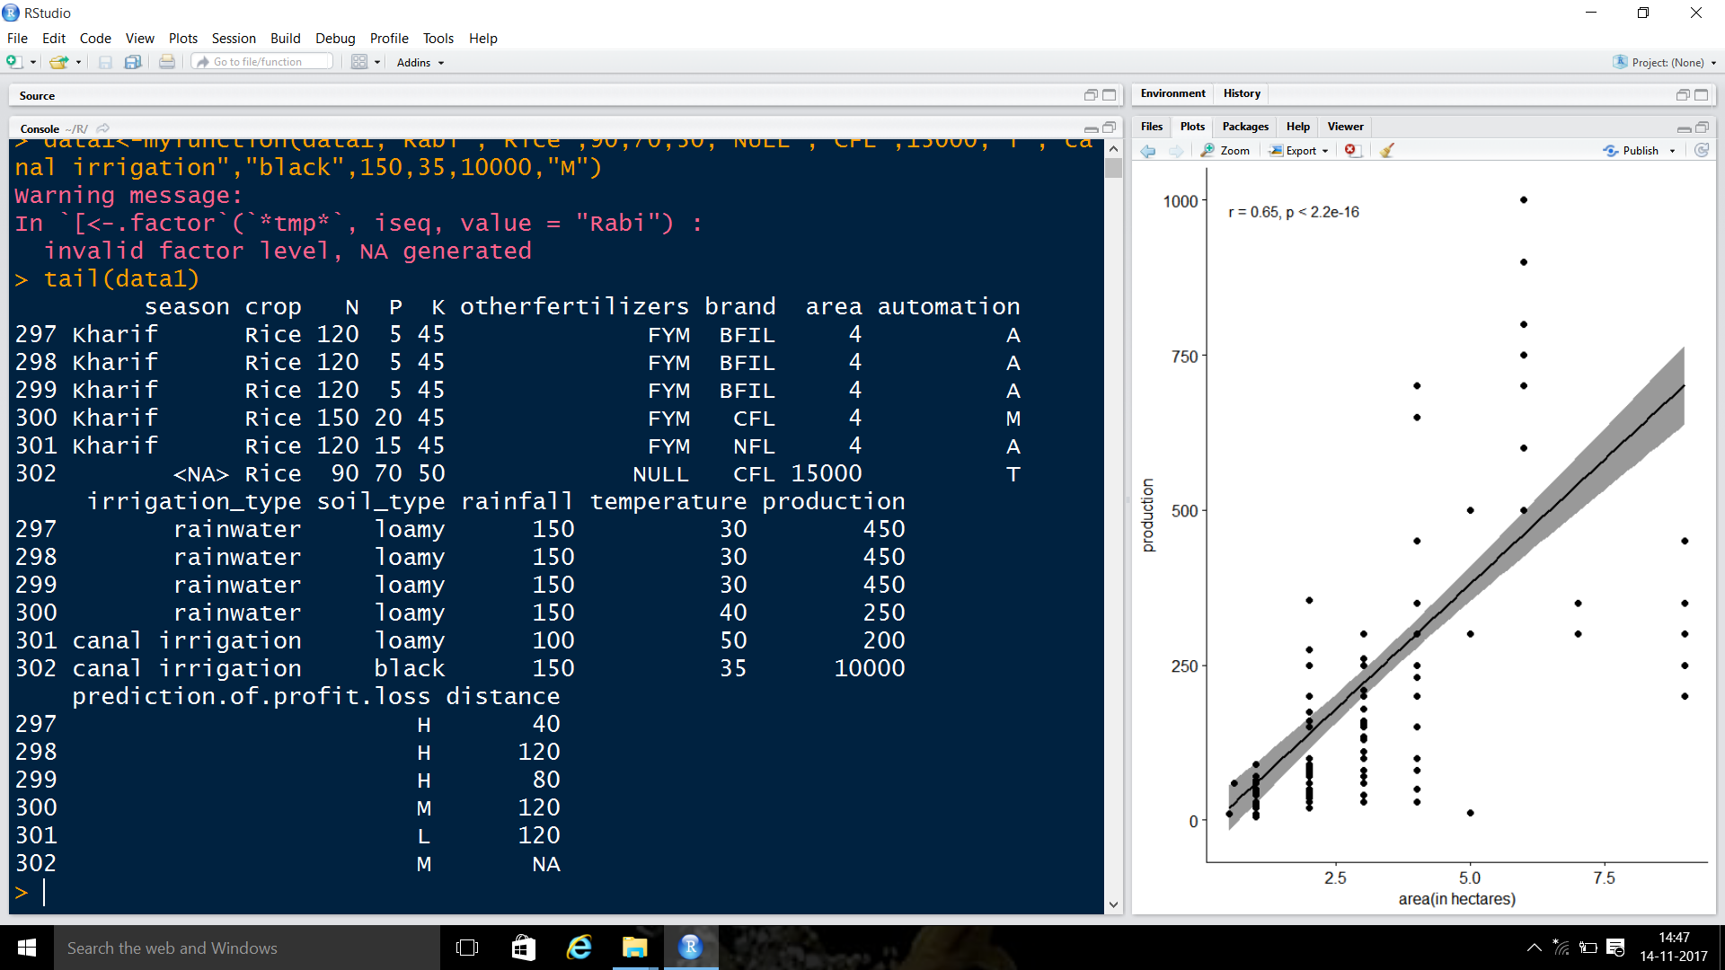

NEWLY INSERTED 302 TUPLE AND THE SCATTER PLOT FORMED WITH THE DATASET

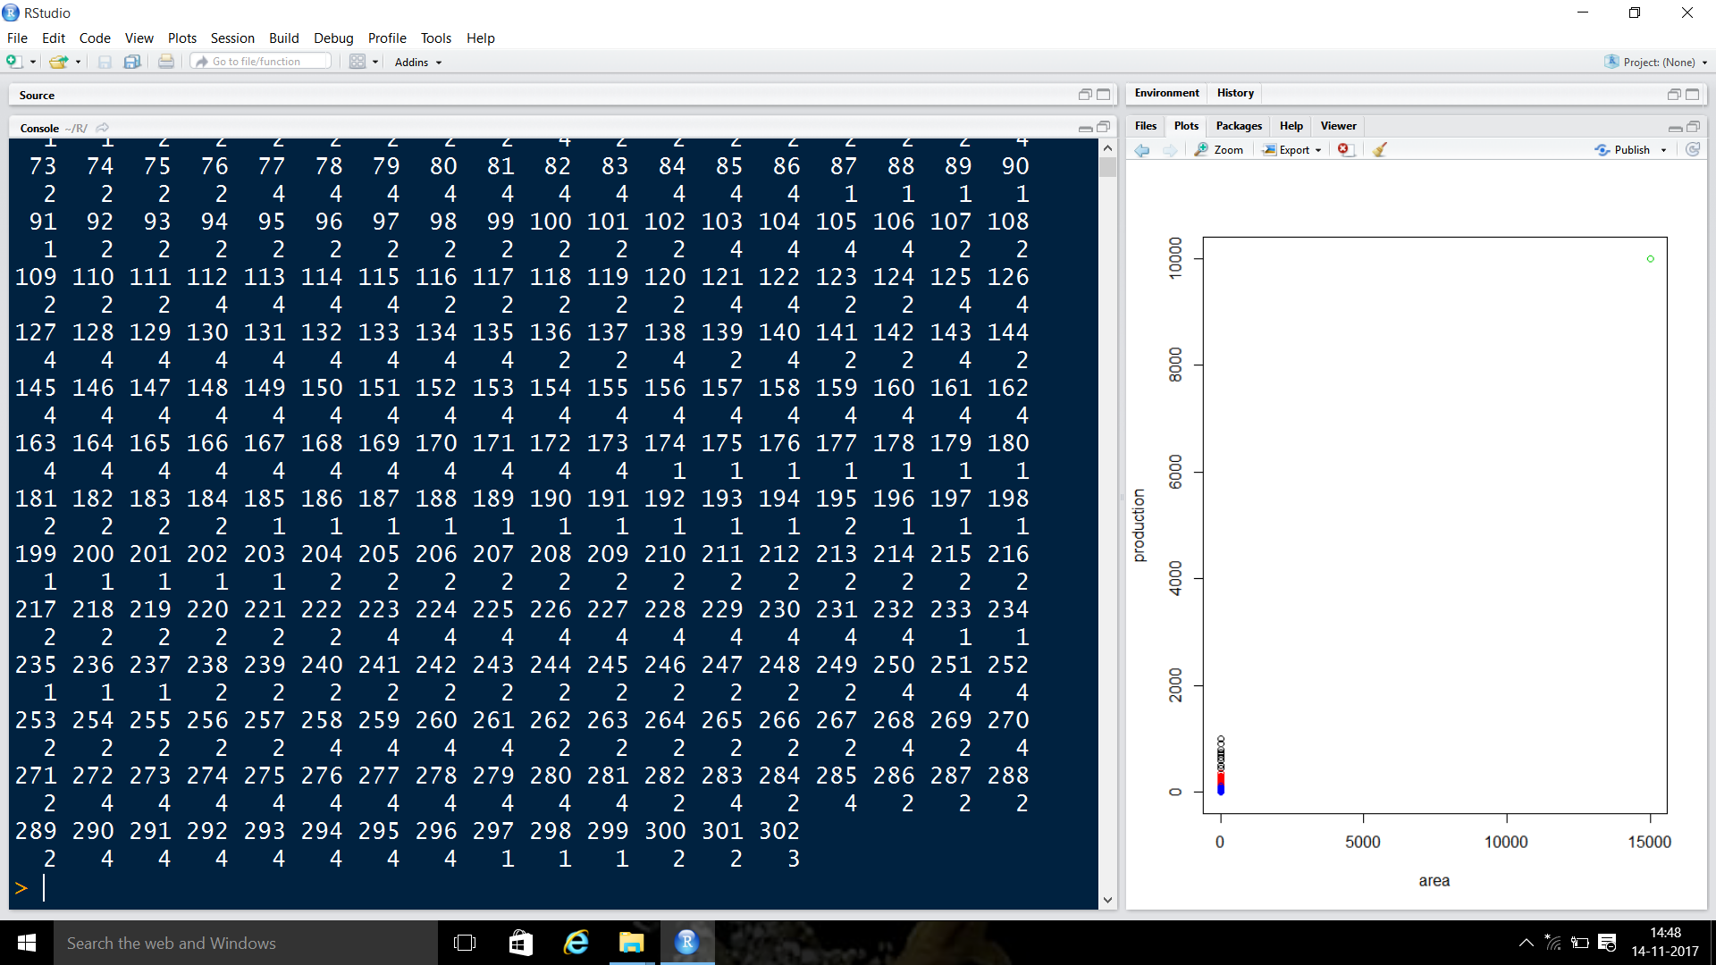

CLUSTER PREDICTED FOR NEW DATA

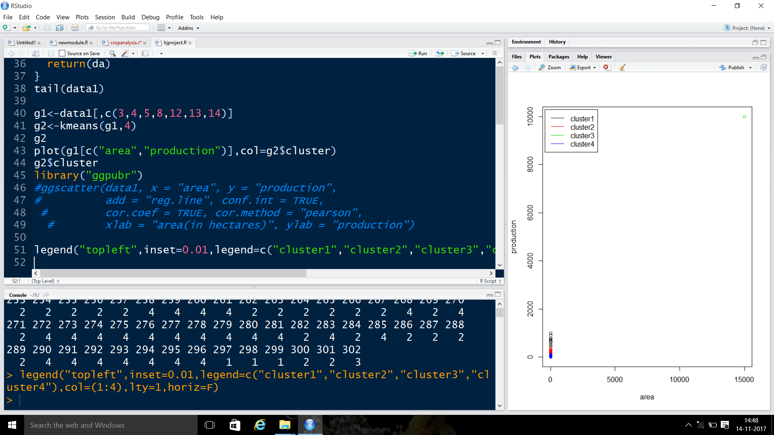

CLUSTER PLOT WITH LEGEND

MODULE3:

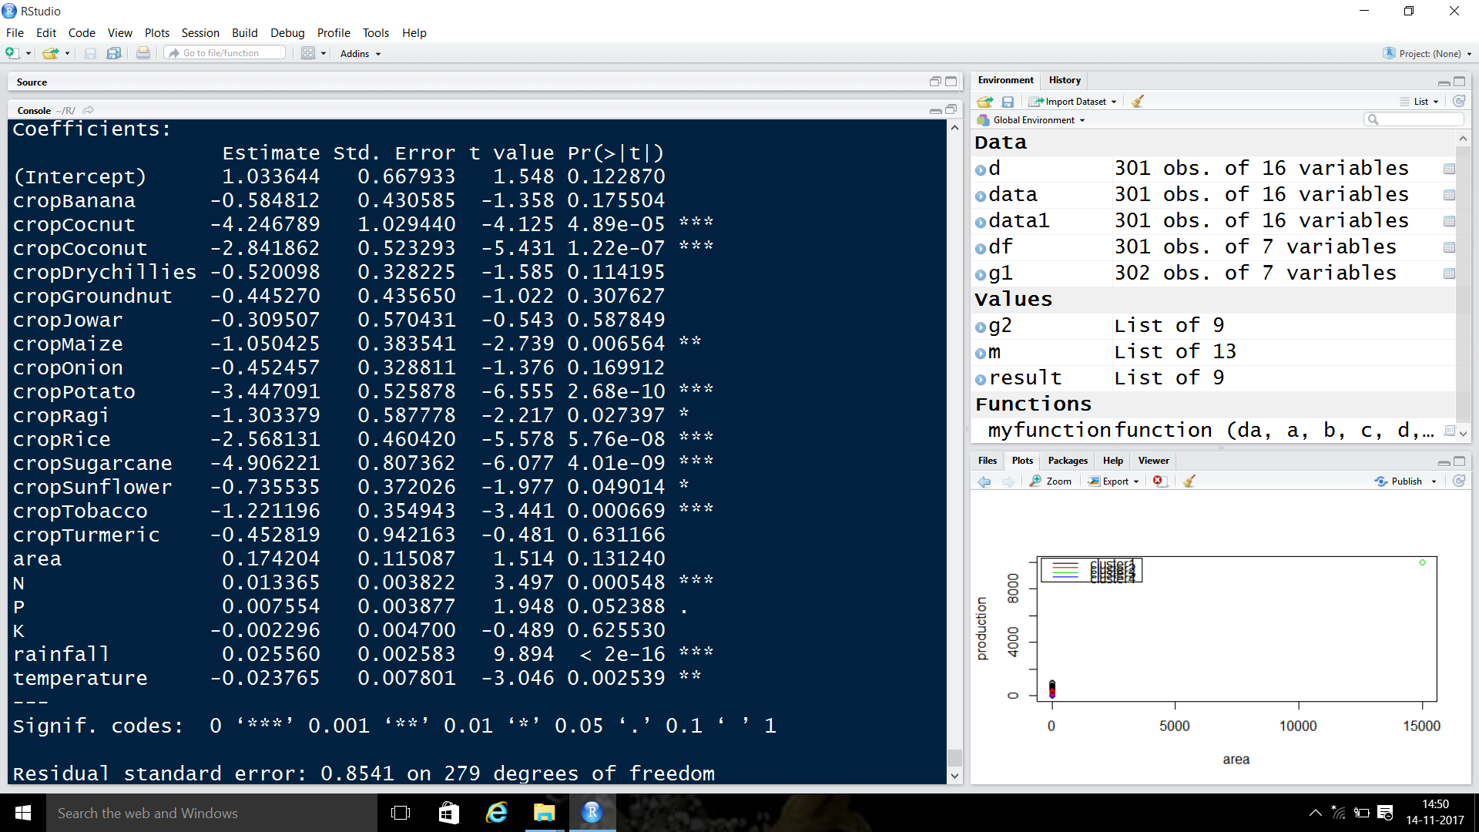

THE LEARNING MODEL WHICH SHOWS HOW THE INDEPENDENT VARIABLES EFFECT THE DEPENDANT VARIABLE

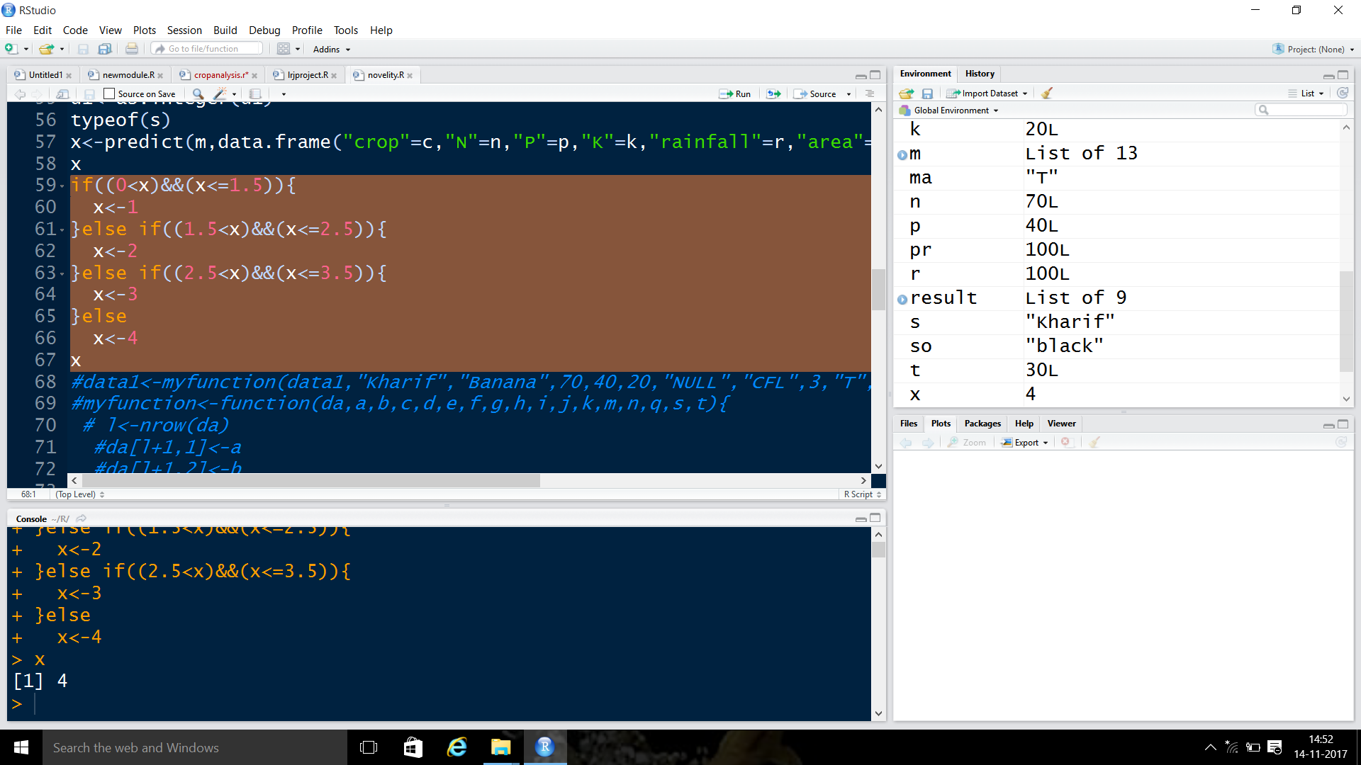

PREDICTED CLASS LABEL FOR NEW TUPLE BEFORE TAKING DISTANCE INTO CONSIDERATION

MODULE4:

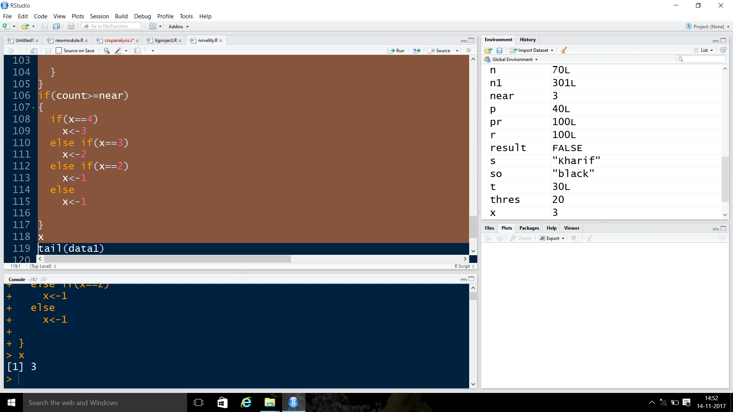

AFTER TAKING DISTANCE INTO CONSIDERATION

MODULE5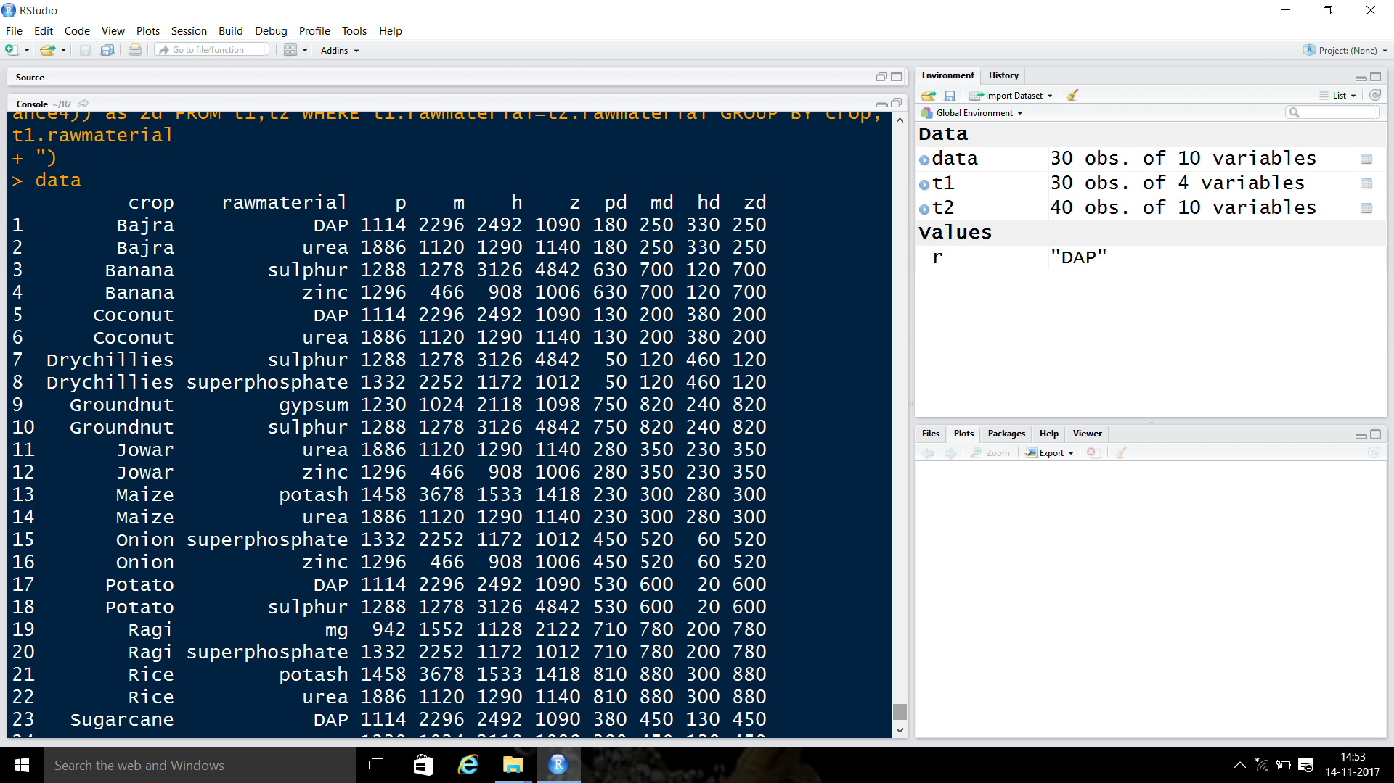

FOR THE PARTICULAR CROP THE AVERAGE PRODUCTION AND DISTANCE IN DIFFERENT STATES

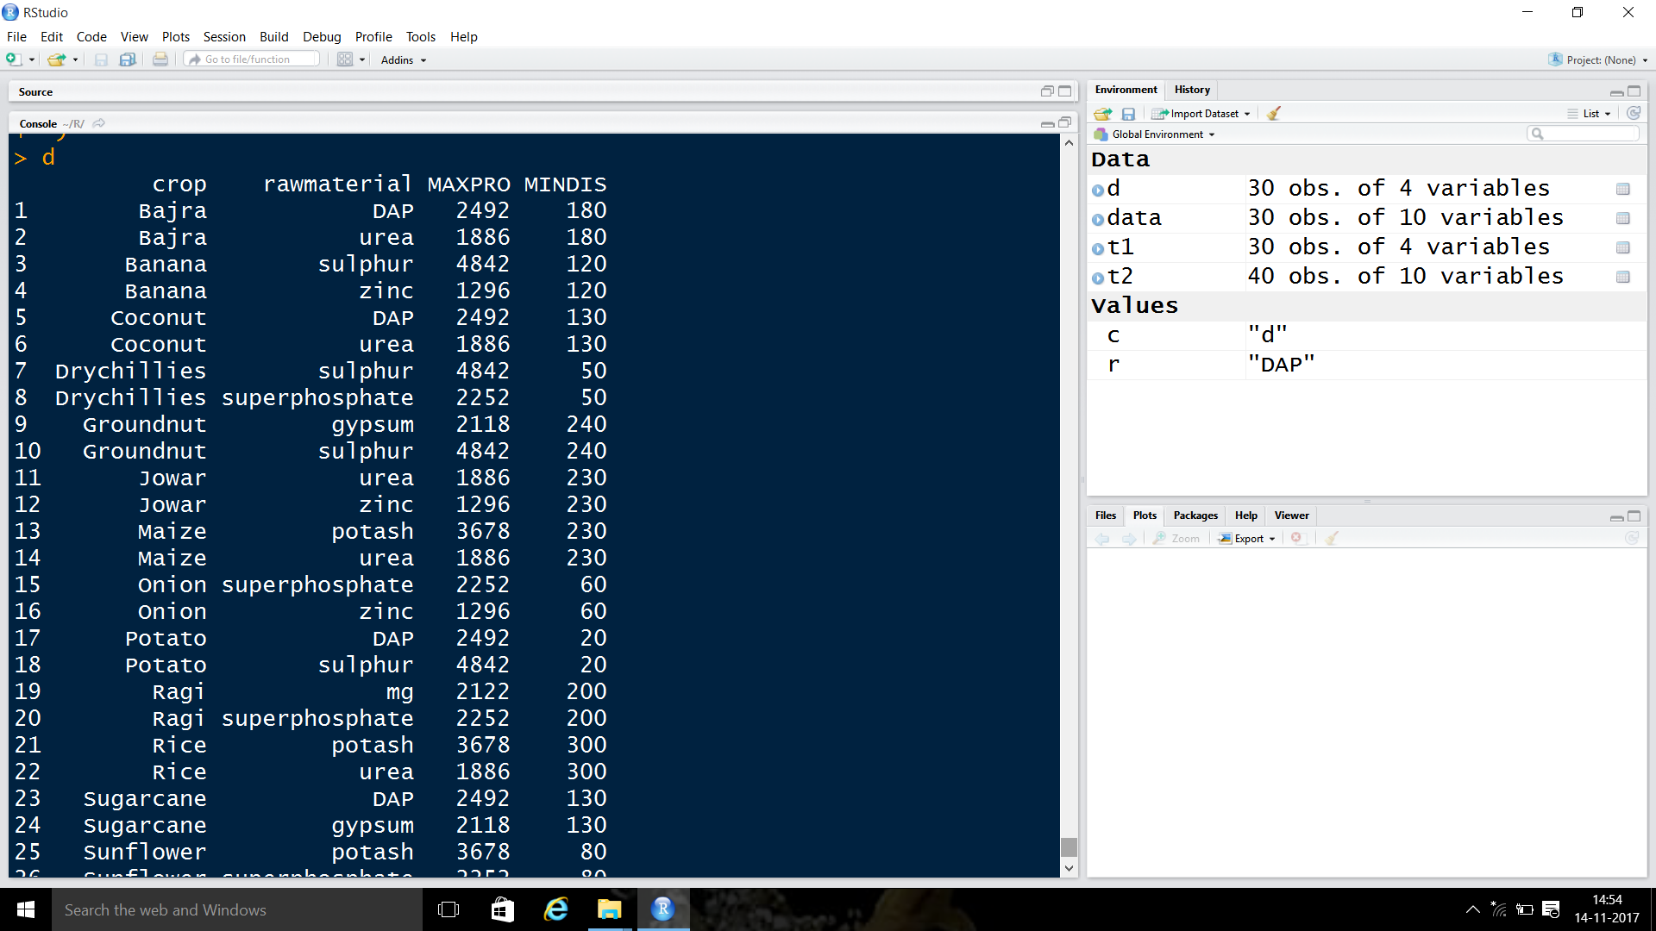

FOR A PARTICULAR CROP WE ARE TELLING THE MAXIMUM PRODUCTION VALUE IN OTHER STATES AND MINIMUM DISTANCE VALUES WHEN COMPARED TO ALL OTHER STATES

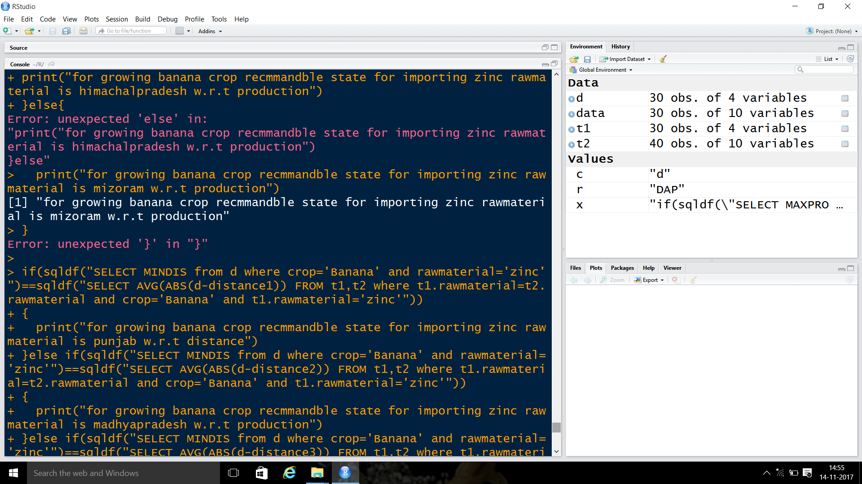

PREDICTING THE BEST STATE FOR IMPORTING RAWMATERIAL IN TERMS OF MAX PRODUCTION

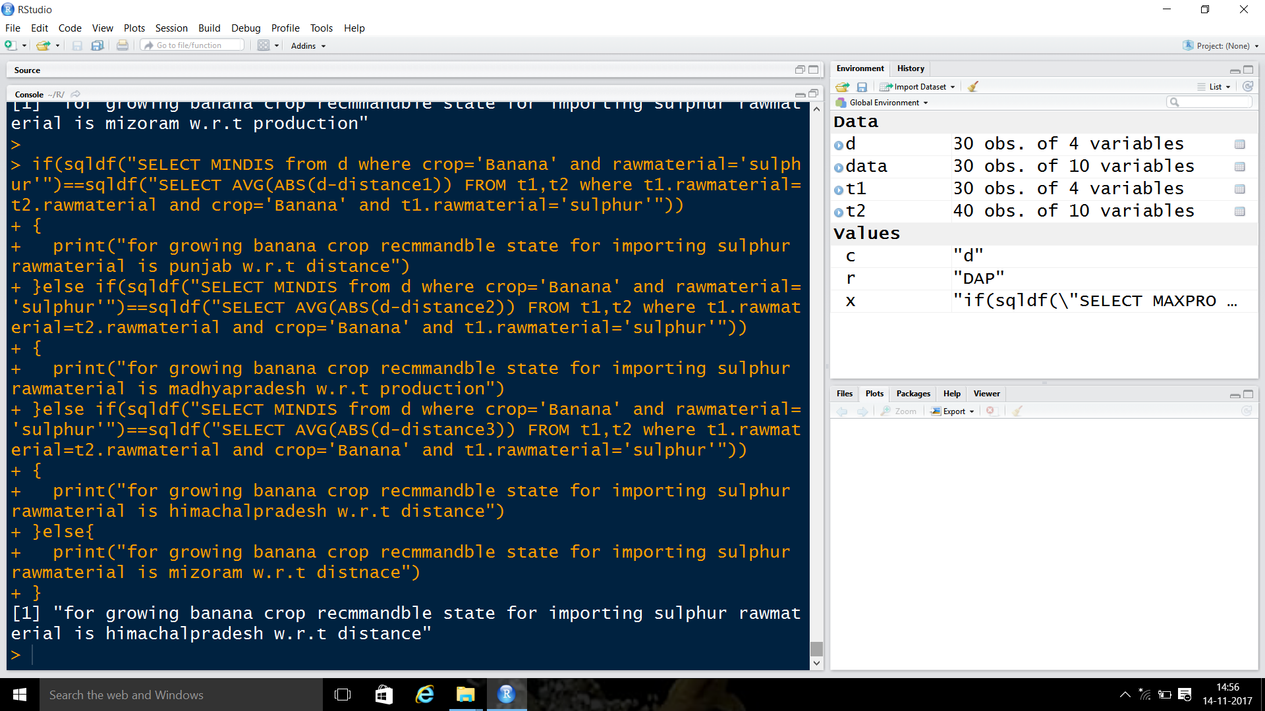PREDICTING THE BEST STATE FOR IMPOTING RAWMATERIAL IN TERMS OF MINIMUM DISTANCE

WEKA:

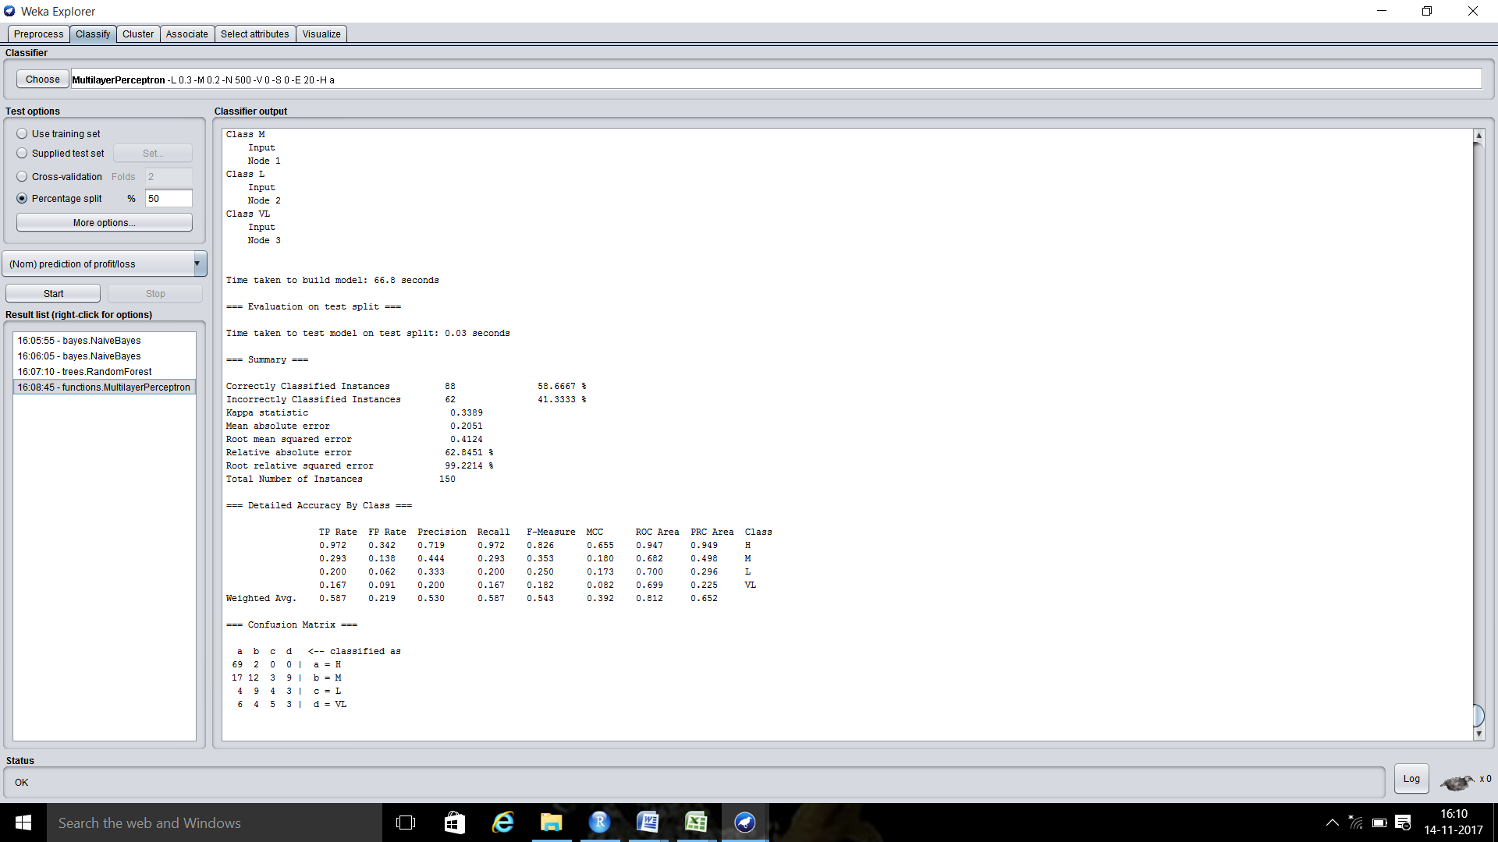

ACCURACY WITH ANN:58%

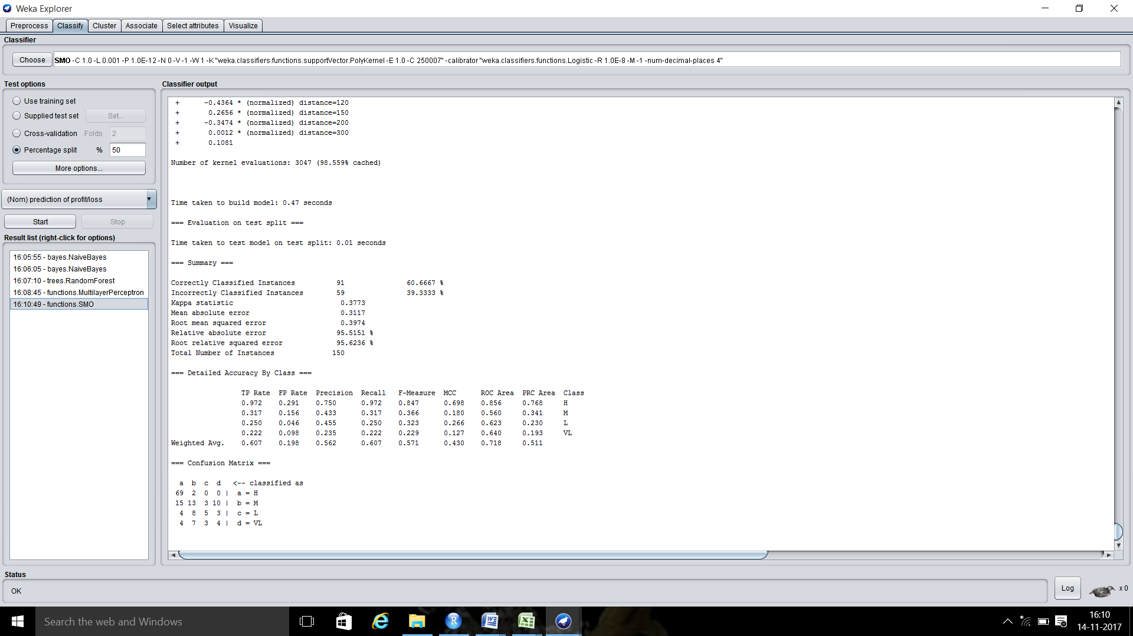

ACCURACY WITH SVM:61%

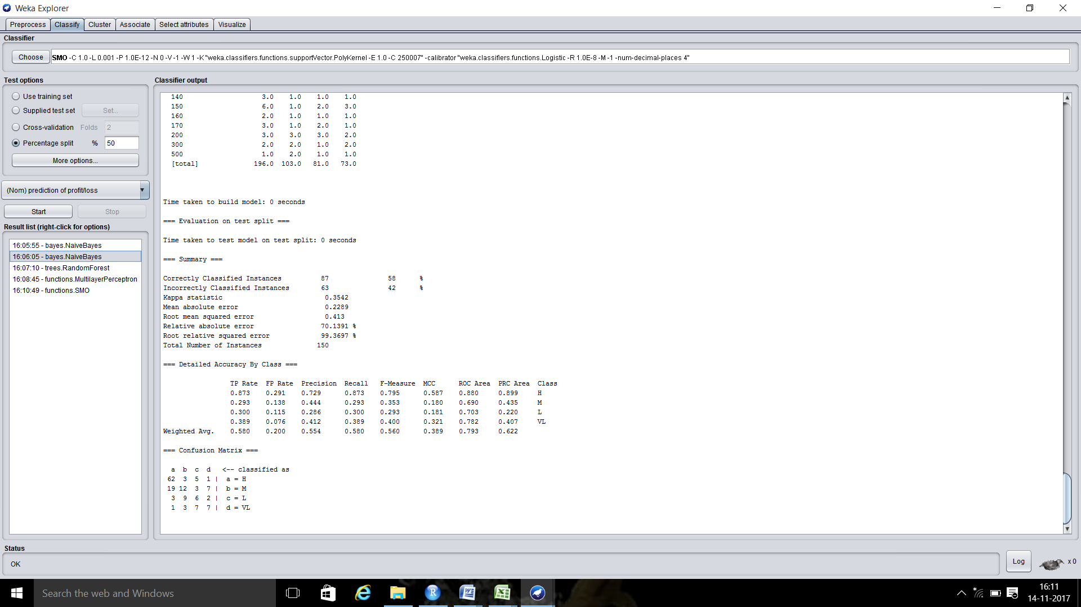

ACCURACY WITH NAIVEBAYES:58%

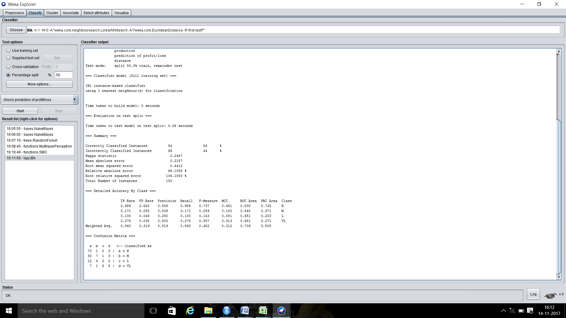

ACCURACY WITH KNN:56%

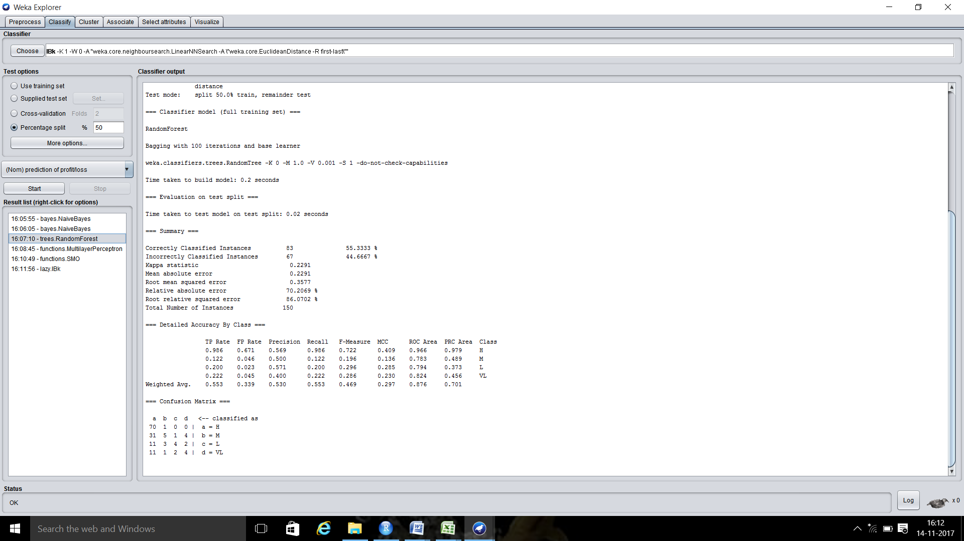

ACCURACY WITH RANDOM FOREST:55%

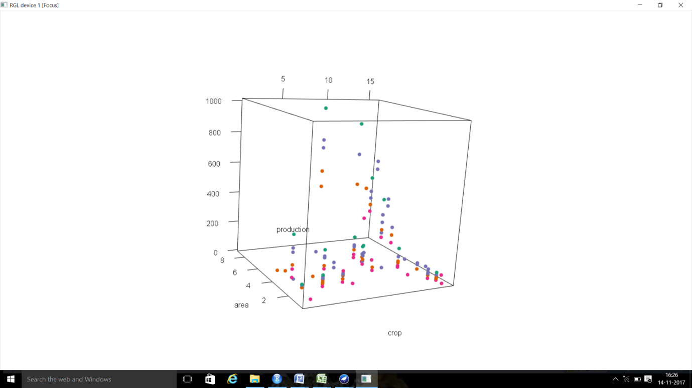

3 D SCATTER PLOT WITH AREA,PRODUCTION,CROP